Maximum clique problem

Given a group of vertices some of which have edges in between them, the maximal clique is the largest subset of vertices in which each point is directly connected to every other vertex in the subset.

The maximum clique problem has many equivalent formulations as an integer programming problem, or a continuous nonconvex optimization problem.

Let S denote the set of all maximal independent sets of G. We used the following formulation:

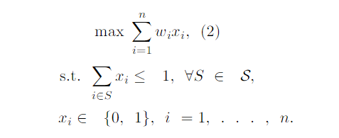

We tested on the following instances of the problem:

|  |  |  |  |  |  |
| --- | --- | --- | --- | --- | --- |
| Instance | Vertices | Edges | Best Known | Found | Duration |
| C125.9 | 125 | 6963 | 34 | 34 | 1.22 s |
| C250.9 | 250 | 27984 | 44 | 43 | 16:12 min |
| C-FAT200-1 | 200 | 1534 | 12 | 12 | 11.96 s |
| C-FAT200-2 | 200 | 3235 | 24 | 24 | 7:34 s |

<https://www.researchgate.net/publication/227238953_The_Maximum_Clique_Problem>